**Acidity of Hexahydrate Complexes:**

**Introduction:**

**Research Question:**

Is there a relationship between the charge density of the central transition metal ion of a hexahydrate complex and the pH of the solution that it forms in water?

**Background Research:**

I first came across this idea while investigating complexes and reading that when a transition metal ion salt is submerged in water, that the complex formed will create an acidic solution. This intrigued me as it is not a solution that I would typically think to be acidic and, it is not covered or discussed in the IB curriculum. In my investigation, I became absorbed in the concept and exploring it trying to figure out why my assumptions about this type of solution would be incorrect. Complexes are interesting to me as it is one of those instances where physics and chemistry meet (as they often do). How complexes are coloured, with the promotion of electrons and other basic quantum physics phenomena. This is what sparked my interest in complexes, and to the final idea of my IA.

Complexes are compounds formed when transition metal ions have neutral or negative ions or compounds bond to them with coordinate covalent bonds. Complexes form acidic solutions while dissolved in water. This is represented by the chemical formula below. For this example iron(III) hexahydrate will be used:

[1]

Below is an image of the structure of the complex:

[2]

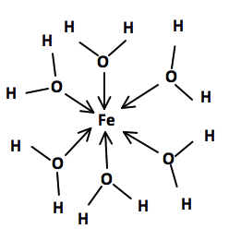The reason why complexes form acidic solutions when dissolved in water is to do with the charge of the central metal ion and the structure of the ligands surrounding it:

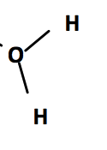

$$δ_{+}$$

$$δ_{-}$$

$$δ_{+}$$

In the diagram to the left, the dots represent the electrons in the bond.

As seen in the diagram above, the oxygen is more electronegative than the hydrogen, causing the electrons in the bond between the hydrogen and oxygen to be located closer to the oxygen than the hydrogen.[3] Further pulling away the electrons from the hydrogen is the charge of the central metal ion.[4] The Iron in this case has a very positive charge at 3+ and attracts the negatively charged electrons in the bond between the hydrogen and oxygen, this pulls the electrons further away from the hydrogen.[5] This creates an acidic solution as the water which is amphiprotic acts as a Brønsted-Lowry base and is looking to gain a hydrogen. Because of the electrons in the bond being located further away from the hydrogen, the hydrogen is easier for the water to remove the hydrogen and form hydronium. By the definition of pH $–\log{[H_{3}O^{+}}]$, as there is more hydronium formed, the pH of the solution decreases and makes it more acidic. This process can be repeated to remove another hydrogen ion from the water ligands surrounding the iron(III):[6]

[7]

This then can happen again:

[8]

This process should stop here as the complex is now a neutral complex and will no longer dissolve in water, this causes the formation of a precipitate.

**Hypothesis:**

If there is a correlation between the charge density of a complex and the equilibrium pH of the solution, then the higher the charge density of the central metal ion, the lower the pH of the equilibrium solution. This is as the higher charged metal central ion will attract the electrons in the bond between the oxygen and the hydrogen away from the hydrogen more than the oxygen already does. This hydrogen ion will then form with the water molecule to form hydronium.

**Variables:**

|  |  |  |
| --- | --- | --- |
| **Independent Variables** | **Dependent Variables** | **Controlled Variables** |
| Charge Density | pH | Concentration |
|  |  | Stir rate |
|  |  | Reaction Time |
|  |  | Temperature |

**Assumptions:**

**Hydrates:** In this experiment, it is necessary to assume that when the transition metal ion compounds were dissolved in water that for the most part, they formed hexahydrate complexes. While through research, it was determined that these ions will form hexahydrate solutions and some exclusively, however, it is possible that while for the most part, the solutions are hexahydrate that there are some instances such as copper(II) and iron(III) where this will not occur. This keeps the variables affecting the pH are the same for all of these trials.

**Equilibrium:** It was also assumed that the pH that was obtained from the pH meter at the end of the duration of the reaction was the equilibrium pH. This allows for the comparison of the relative strengths of the acids and have a comparable point so that the pH’s of different solutions can be compared.

**Transition Metal Ions Act as a Sphere:** For the purpose of determining the charge density of an ion, it will be assumed that the volume of the ion is spherical in nature. While this is not true, it is difficult to calculate the volume of the composite shape of an ion and will not likely be very significant. As such, it will be assumed that the charge of an ion is spread over its volume as a sphere.

**Procedure:**

1. 200 ml of water was measured into a 250ml graduated cylinder. This water was poured into a 250 ml beaker. This beaker will be known as beaker 1. The stir bar placed into the beaker and placed onto the stir plate.
2. A retort stand was set up above the beaker with an attachment for the pH meter.
3. The pH meter was connected to the Lab Quest 2 and placed into beaker 1.
4. The stir was set to its highest value and the Lab Quest 2 was started. The trial length was set to 120 s.
5. 8.11g of FeCl3 was massed out so that it formed a 0.25M solution in beaker 1. (Mass is for anhydrous salt)
6. After the trial the pH sensor was cleaned in water and the chemicals were poured into a waste beaker.
7. Steps 1-9 were repeated 3 times per chemical.
8. Steps 1-10 were repeated for FeCl2 (6.34g), AlCl3 (6.67g), CuSO4 (7.98g), and MnSO4 (7.55g) transition metal ions so that a 0.25 molar solution was created. (Mass is for anhydrous salts)

**Apparatus:**

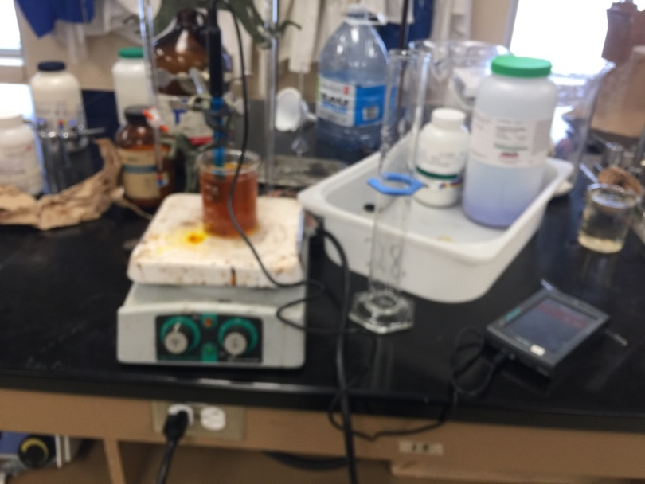

**Materials:**

1. 2 250ml beakers.
2. Stir Plate
3. Stir Bar
4. 250ml Graduated cylinder
5. Lab Quest 2
6. pH Probe
7. Mass scale
8. 50ml beaker
9. Retort stand
10. FeCl3, FeCl2, AlCl3, CuSO4 and MnSO4

**Safety:**

**Dealing with acidic solutions:** As with any lab, especially those dealing with acidic solutions, it is important to protect clothing and eyes from potential damage, this was achieved by wearing lab coats and safety glasses. When handling these solutions, there were times when the acidic solutions would come into contact with my skin. In these situations, cold water would be poured onto the region where the acid had been and after a short while, work was resumed.

**AlCl3:**

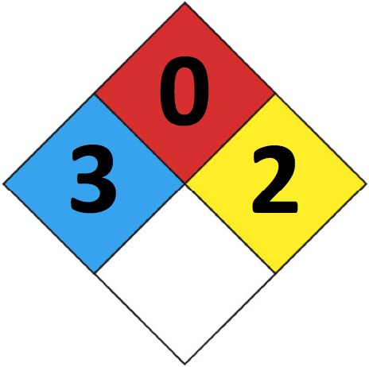[9]

**Health:**

The level 3 indicates that short exposure to aluminum(II) chloride could lead to serious temporary and/or moderate residual injury.

**Reactivity:**

The level 2 indicates that when at high temperatures or pressures that aluminum(III) chloride has the potential to undergo a violent chemical change.

**Acidic:**

Aluminum (III) chloride is also known to be very acidic.

**Handling:**

Aluminum(III) chloride was the most dangerous chemical I worked with and as such, took extra precautions while using it. If there was any aluminum(III) chloride that came into contact with my bare skin while working with it, it was washed off with cold water. Extra precautions were taken not to inhale the chemical and limit exposure to it.

**FeCl3:**

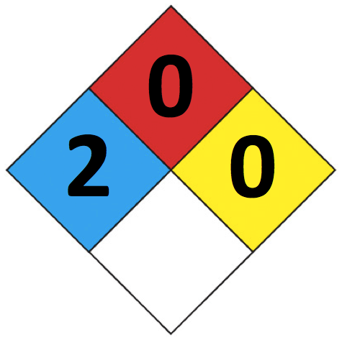**[10]**

**Health:**

The level 2 indicates that intense or prolonged exposure to iron(III) chloride could cause temporary incapacitation or possible residual injury.

**Toxic (Oral):**

Iron (III) chloride is known to be very dangerous to ingest and toxic in nature.

**Acidic:**

Iron (III) chloride is known to be very acidic.

**Handling:**

Iron(III) chloride being known to be toxic and coming in a small granular form that is very powdery, is a hazard for ingestion and inhalation. As such, I made sure not to inhale it. When coming into contact with the chemical, the area was washed off.

**FeCl2**

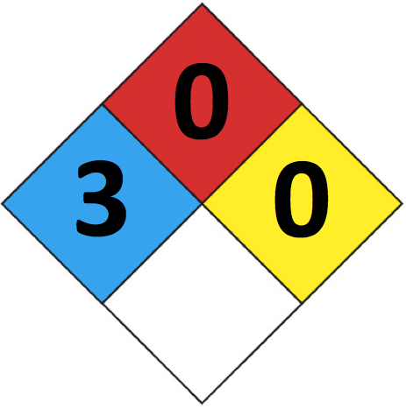[11]

**Health:**

The level 3 indicates that short exposure to iron(II) chloride could lead to serious temporary and/or moderate residual injury.

**Handling:**

Since iron(II) chloride is a potentially hazardous chemical if I came into contact with the chemical, the area was washed and exposure was attempted to be limited.

**CuSO4:**

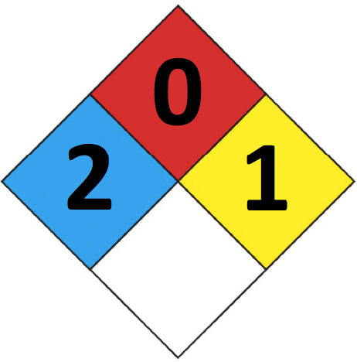**[12]**

**Health:**

The level 2 indicates that under intense or prolonged exposure to copper(II) sulphate could cause temporary incapacitation or possible residual injury.

**Reactivity:**

The level 1 indicates that copper(II) sulphate is normally stable, but at high temperatures and pressures has the potential to become unstable.

**Pollutant:**

Copper (II) Sulphate is known to be a dangerous pollutant.

**Handling:**

Copper (II) sulphate is not a particularly dangerous compound and while taking general laboratory precautions there were no additional precautions.

**MnSO4:**

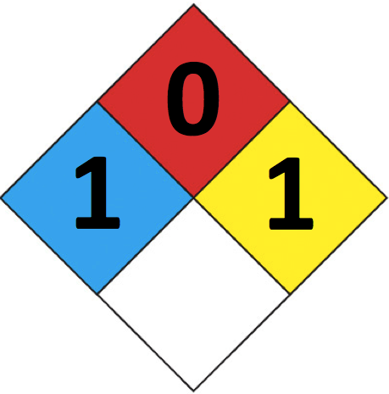**[13]**

**Health:**

The level 1 indicates that exposure to manganese(II) sulphate may lead to irritation and minor residual injury.

**Reactivity:**

The level 1 indicates that manganese(II) sulphate is stable, but at high temperatures and pressures has the potential to become unstable.

**Handling:**

Manganese(II) sulphate is the least dangerous compound that was worked with and poses very little danger to a person.

**Environment:**

With using chemicals that are potentially environmentally dangerous, or known to be pollutants, chemicals had to be disposed of so that the environment was unharmed. To achieve this, chemicals were placed into a waste beaker. This waste beaker will be left until the water evaporates, and there are only the chemicals left. At that point, the chemicals can be disposed of properly, so that the environment is not additionally polluted by pouring reagents down the sink.

**Analysis:**

In figures 2.1 and 2.2, it is important to note that there are error bars present, however they are so small that they are difficult to notice. This is since the experiment used the Lab Quest 2 and its pH sensor, the values have a lot of digits, and there is little deviation especially when the solutions reach their equilibrium they will have very similar values, especially when they move further away from the starting pH. For each of the five complexes, there were three trials done to determine the deviation of the averaged values.

**Figure 2.1**

**Figure 2.2**

|  |  |  |  |  |
| --- | --- | --- | --- | --- |
| **Element** | **Charge** | **Radius ($m$)** | **Charge Density ($m^{-3}$)** | **Equilibrium pH** |
| Al | 3+ | $$5.4*{10}^{-11}$$ | $$4.5*{10}^{30}$$ | $$3.46±0.04$$ |
| Fe | 2+ | $$6.1*{10}^{-11}$$ | $$2.1*{10}^{30}$$ | $$4.07±0.05$$ |
| Fe | 3+ | $$5.5*{10}^{-11}$$ | $$4.3*{10}^{30}$$ | $$1.95±0.06$$ |
| Cu | 2+ | $$7.3*{10}^{-11}$$ | $$1.2*{10}^{30}$$ | $$5.12±0.04$$ |
| Mn | 2+ | $$8.3*{10}^{-11}$$ | $$8.4*{10}^{29}$$ | $$3.20±0.03$$ |

**Figure 2.3**

**Calculations:**

$$Mass_{Reagent}=Mass_{Molar}*M*v$$

$$Mass_{MnSO_{4}}=151.1g_{MnSO_{4}}mol^{-1}(0.25mol L^{-1})(0.200L)$$

$$Mass_{MnSO_{4}}=7.55g_{MnSO_{4}}$$

$$Error=\frac{pH_{max}-pH_{min}}{2}$$

$$Error=\frac{3.22-3.17}{2}$$

$$Error=0.03$$

$$Let the charge density be represented by D_{c}$$

$$Let the ionic charge be represented by C_{I}$$

$$D_{c}=\frac{C_{I}}{V_{Ion}}$$

$$D_{c}=\frac{C_{I}}{\frac{4}{3}πr^{3}}$$

$$D_{c}=\frac{3}{\frac{4}{3}π{(55*{10}^{-12})}^{3}}$$

$$D_{c}= 4.31*{10}^{30}m^{-3}$$

**Observations:**

**Qualitative:**

**AlCl3:**

* Orange, granular, crystals, somewhat powdery.
* Clear colourless solution.
* All crystals were completely dissolved by the end of the trials.

**FeCl2:**

* Turquoise granular crystals, much larger than salt or sugar, but still small.
* Bright green complex formed. Clear in solution.
* All crystals dissolved by the end of trials.

**FeCl3:**

* Brown and yellow crystals, fine like a powder, clumped.
* Formed an orange complex. Clear in solution.
* Iron (III) chloride left in the bottom of massing beakers.
* After prolonged periods of time a tinge of red forms in the beaker.
* All crystals dissolved very quickly.

**CuSO4:**

* Large blue crystals.
* A blue complex was formed. Clear in solution.
* Copper (II) sulphate crystals take a very long time to dissolve, not all crystals dissolved by end of 120s trial or after.

**MnSO4:**

* A fine, light pink crystal powder.
* Some manganese (II) sulphate stuck to the bottom of the massing beaker.
* At first a very light pink complex was formed.
* After stirring for a while, the complex turned white and translucent.
* After approximately 110s the complex would turn colourless.
* All crystals were dissolved.

**General:**

* In all cases, there was a very sudden drop in pH before the pH curve leveled out.
* Occasionally there would be some of the compound that while pouring did not make it into the stirring beaker.

**Error Analysis:**

**Formation of Hexahydrate Complexes:**

This is not so much an error as a limitation of the lab its self. During the experiments, the colour of the solutions indicated the presence of hexahydrate complexes, it is impossible for me to know truly whether there was the formation of hexahydrate complexes. The point of keeping the complexes hexahydrates is to keep the factors affecting pH to the charge density of the atom rather than the structure of the complex. If the structure of the complex changes it is difficult to determine exactly how this would affect the pH of the equilibrium solution. If the complex formed by the water ligands was greater than a hexahydrate complex with an octahedral structure the complex would be larger, and this separation with the very positive transition metal and the shielding from the other ligands means that the pH of the solution would increase. If the complex that was formed had fewer than six ligands. There will be less interference with the ligands and the molecule will be smaller, therefore, the ligands that are closer to the central transition metal ion will have the electrons in their bonds between the hydrogen and the oxygen pulled further away from the hydrogen. This makes it easier for the amphiprotic water to act as a Brønsted-Lowry base and remove the hydrogen from the ligand to form hydronium. It is difficult to find a way to eliminate an error such as this one, this is as it is difficult to tell what complex has formed. Iron (III) is known to form both hexahydrate and tetrahydrate complexes, however, it forms far more hexahydrate, so this is not likely an error.[14] Iron (II) is known to only form hexahydrate complexes.[15] Aluminum (III) will form hexahydrate complexes.[16] Copper can form a number of hydrates, including pentahydrate, however, the hexahydrate ion will be formed most.[17] [18] Manganese (II) will form a hexahydrate complex.[19] [20]However, in an attempt to keep the complexes as hexahydrates, there was an excess of water added so that no complexes smaller than hexahydrate was formed. In the future, this could be corrected by purchasing these chemicals for the experiment from a professional lab that has the means to separate these different complexes. Another way of controlling this variable is to use metals that can only form hexahydrate complexes. These metals include iron(II), nickel(II), chromium(II) and vanadium(II). Doing this ensures that the data is not skewed by means of molecular architecture.

**Different solubility:**

Each reagent took different amounts of time to dissolve, with iron (III) chloride dissolving the fastest and copper (II) sulphate taking the longest to dissolve, this affects the equilibrium pH. Since the copper (II) sulphate took by far the longest to dissolve, its pH moved accordingly, very slowly relative to the other trials. This means that it is possible that the copper (II) sulfate was not at its equilibrium. This difference is not likely to be of major consequence as when trials were extended past the 120s mark, there was very little change noticed across this time interval. Over another 120s period, the pH moved from 5.09 to 5.03. This is such a small difference that it can be excluded from the data. In general, if the compound takes longer to dissolve than another over a short trial period, then the final pH of the less soluble compound will be higher assuming that eventually they will have the same equilibrium pH. This error can be corrected by making the trial periods over a longer period of time, allowing all solutions to make it to their equilibrium pH.

**Un-Distilled Water:**

In these trials, regular tap water was used. Because of the carbonic acid that is formed in the tap water, it has a lower pH than distilled water. The pH of water used in this experiment varied from 6.00 to 7.4, while the upper range of those values is slightly basic, the majority of trials indicate that the water is slightly acidic. This means that the pH of the final solution has the potential to be very slightly higher, or for side reactions to take place between the dissolved compounds and the minerals etc. in the water. These are all very unlikely to have had a major effect on the lab proceedings. Since pH is a logarithmic scale, the concentration of hydronium increases 10x for each pH the scale moves down. So, at higher pH’s as seen in the iron (III) chloride data, the starting pH plays little role in the final pH as the concentration of hydronium is a number of orders of magnitude higher than it. However, when looking at the copper (II) chloride data where the final pH is around 5, the starting pH will have an effect of the trial as the concentration of hydronium is only one order of magnitude higher than that of the starting concentration. This could be very easily corrected by using distilled water.

**Iron (III) Chloride, Manganese (II) Sulfate sticking to beaker:**

During the trials that used Iron (III) Chloride and Manganese (II) Sulfate during the massing there was a small amount of the chemicals left in the beaker. This likely didn’t affect the data as the difference in concentration would be minute. However, if there was a large enough mass of either of those chemicals to affect the concentration, then the pH would change. When the concentration of an acidic solution decreases, so too does the concentration of hydronium that the water produces change. This decrease in concentration will cause the pH to go up. This would be very small as the amount of Iron (III) Chloride and Manganese (II) Sulfate that was left in the beaker was small. In the future this could be corrected by not having the Iron (III) Chloride get wet. When the Iron (III) Chloride gets wet it is very sticky and as such, is difficult to remove when trying to poor the re-agents into the beaker. This could further be corrected by taking the beaker back to the scale and massing it again, then by adding the reagent that it is missing the trial can continue.

**Evaluation:**

The experiment showed that there is a correlation between the charge density of the central transition metal ion and the pH of the solution that it forms. This is as was predicted in the hypothesis, that as the charge density increased, the pH of the equilibrium solution decreased. This is expected as when the charge density of a central transition metal ion in a complex increases it will exert a greater force on the negatively charged electrons found in the bond between the oxygen and hydrogen. Since it is the oxygen that forms a coordinate covalent bond with the central transition metal ion the hydrogen if further away from the central transition metal ion. This will cause the electrons to be pulled away from the hydrogen atoms more than with the existing difference in electronegativity between the oxygen (3.4) and the hydrogen (2.2). With the electrons, so far away from the hydrogen, its bond with the oxygen is easily broken by the amphiprotic water, which acts as a Brønsted-Lowry base. When the water takes the hydrogen from the water ligands, it forms hydronium and based on the definition of pH, $pH=-log⁡([H_{3}O^{+}$], the pH decreases. As can be seen in Figure 2.1, there is a grouping between the 2+ charged ions and the 3+ charged ions in both their charge density and their pH. However, an interesting point in Figure 2.1 and 2.3 is the similarity in charge density between Aluminum (III) and Iron (III), and how different their equilibrium pH’s are. Aluminum (III) has a charge density of $4.5*{10}^{30}charges m^{-3}$ whereas iron (III) has less charges per $m^{3}$ at $4.3*{10}^{30}charges m^{-3}$. However, the pH’s are significantly different as the pH of the aluminum (III) has an equilibrium pH of 3.46 whereas iron (III) has an equilibrium pH of 1.97, a difference in the concentration of hydronium by more than a factor of ten. This is difficult to quantify, especially while only looking at the factors that this experiment uses. This difference points to a difference in their molecular architecture and the formation of other complexes. Iron(III) will for the most part form hexahydrate complexes and in small quantities, tetrahydrate complexes. This points to the aluminum (III) forming different complexes with water, the formation of a hydrate that has more ligands than a hexahydrate complex. This is as the charge of the central metal ion is spread out over a greater volume and the other water ligands act as shielding. This makes it so that the hydrogen atom of the water ligands is less easily removed. This is difficult to determine as there is no way to observe the atomic structure of the complex with the equipment I had available. This error is difficult to quantify if the aluminum(III) didn’t form different complexes. This is because if their molecular architectures are the same and their charge densities are similar, there is little that would point to why their pH’s were different. A similar conclusion can be drawn comparing the pH’s of the aluminum(III) to the manganese(II). The two solutions both had similar pH’s, at 3.46 for the aluminum(III), and 3.20 for the manganese(II). Despite the fact that the aluminum has a higher charge density, $4.5*{10}^{30}charges m^{-3}$ versus $8.4*{10}^{29} charges m^{-3}$, aluminum (III) has a higher pH than the manganese(II). This is difficult to explain, but likely it will be that the aluminum is forming a different complex than is predicted. Especially considering that the manganese still fits within the predicted pH range for a 2+ ion (between 6 and 3)[21]. Though, even amongst hexahydrate complexes, there is a slight overlap between the expected values of the 2+ ions (pH between 6 and 3) and the 3+ ions (pH between 3 and 1).[22] This is very curious, as amongst hexahydrate complexes they would all have the same molecular geometry. Potentially Manganese could be forming other complexes as it has the lowest charge density of the 2+ molecules and despite this, the lowest pH. This is difficult to quantify and points to an unknown factor affecting the pH. This could potentially have to do with the bonds that are formed between the water and the central transition metal ion. If the central transition metal ions form weaker or stronger bonds with the water ligands, the distance between the water and the central transition metal ions will affect how close the electrons in the bond between the hydrogen and oxygen. If this were the case, then the stronger the bond between the water and the central transition metal ion, the more acidic the solution would be. However, this cannot be tested.

Figure 2.2 is an extension of the idea of the ionic charge density, however, looking at the ionic radii instead. Because of the lack of regard for the ionic charge in this consideration it would make sense that the two complexes whose central ionic charge was 3+, having a greater force of attraction to the electrons in the H-O bond, not fitting in a trend line with the 2+ charges. Despite this, the aluminum (III) hexahydrate instead appears to fit in with the trend of the copper (II) hexahydrate and the iron (II) hexahydrate. This is difficult to explain unless, like explained before, it is forming a different complex. In figure 2.2, it appears to point to there being a maximum between the atomic radii and the pH of its complex solution. A point of interest, is that after a certain atomic radius, where the pH is at a max, that the pH then starts to drop again as the atomic radius increases. This should not make sense as atomic radius affects the charge density, and as the atomic radius of an ion increases, its charge density decreases. This indicates that there is another factor that goes into the pH of the equilibrium solution. Since copper(II) is the compound that finds itself close to the max, it should be examined whether the fact that it will form pentahydrate complexes as well as hexahydrates is why it has such a high pH. This doesn’t necessarily make sense as if there were less ligands, the charge would be spread over a smaller area and there would be less shielding from other ligands. So, the fact that the copper(II) forms pentahydrate complexes is not a factor in its high pH.

**Conclusion:**

The results of the lab, followed the predictions made in the hypothesis, that as the charge density of the central metal ion of a hexahydrate complex increased, its equilibrium pH in solution decreased. This is observed in figure 2.1 where pH’s of the 3+ ions are lower than that of the 2+ ions. While this general trend did hold up, there were unknown variables which affected the results of this experiment. This is shown in the large difference between the pH’s of the aluminum(III) complex and the iron(III) complexes despite their similar charge density. Another irregular point is the pH of the manganese solution, with a pH of 3.20, it is lower than the aluminum(III) despite having a much lower charge density. Another strange point is that manganese(II) has the lowest pH of the 2+ ions despite having the lowest charge density. This would likely be accounted for in the molecular architecture and the formation of different complexes. Though, there are still instances where the molecular geometry cannot account for this phenomenon, this is observed in the overlap between equilibrium pH of hexahydrate complexes with 2+ and 3+ charged central transition metal ions. This problem occurs as according to my research, it is possible for both 2+ charged complexes and 3+ charged complexes to have a pH of 3. This could not be checked in this lab, but would be interesting to discover whether the bonding between the water ligands and the central transition metal ion has an effect on the pH. As such, it is not possible to determine the pH of a hexahydrate complex in solution based on its charge density. However, it can be generally said that the higher the charge density of the central metal ion, the lower the equilibrium pH. To improve this lab, there should be more attention given to examining more complexes. It was my original intention to do 10 trials with various 2+ and 3+ complexes, however due to time restrictions and restrictions on the chemicals available, this was not done. This would allow for a more expansive trend to be developed and examining what differences in the central metal ion affects the pH. By doing this, potentially, the abnormalities in the pH’s of aluminum(III) and manganese(II) could be explained. To improve the quality of the data it might be better to perform the experiment over a longer period than 120 seconds. In the future, trials of 300 seconds or longer should be considered. This would make it so that the solutions were all at their equilibrium pH by the time the trials were finished. By doing so the pH values will be closer to their equilibrium values and in general, more accurate. Distilled water should be used in the future so that there isn’t the potential for the pH’s of the complex to be affected by the starting pH of the water. An interesting addition to this lab would be to look at different complexes of the same transition metal ions and how the number of water ligands affects the pH of the equilibrium solution.

Bibliography:

COMPLEX METAL IONS - THE ACIDITY OF THE HEXAAQUA IONS. (n.d.). Retrieved February 21, 2018, from <https://www.chemguide.co.uk/inorganic/complexions/acidity.html>

Iron(III) chloride. (n.d.). Retrieved February 21, 2018, from <http://sciencemadness.wikia.com/wiki/Iron(III)_chloride>

Iron(III) chloride. (2018, February 17). Retrieved February 21, 2018, from <https://en.wikipedia.org/wiki/Iron(III)_chloride>

Odd Acidity Trend in Hexaaqua Metal Complexes. (n.d.). Retrieved February 21, 2018, from <https://chemistry.stackexchange.com/questions/41038/odd-acidity-trend-in-hexaaqua-metal-complexes>

The Formation of Complex Ions. (n.d.). Retrieved February 21, 2018, from <http://www.docbrown.info/page07/appendixtrans01.htm>

Appendix 1 Hydrated salts, metal–aqua complex ions and their relative acidity. (n.d.). Retrieved March 28, 2018, from <http://www.docbrown.info/page07/appendixtrans01.htm>

Copper(II)sulfate. (2018, March 16). Retrieved March 28, 2018, from <https://en.wikipedia.org/wiki/Copper(II)_sulfate>

Copper;hexahydrate. (n.d.). Retrieved March 28, 2018, from <https://pubchem.ncbi.nlm.nih.gov/compound/14324922#section=Top>

Manganese hexahydrate. (n.d.). Retrieved March 28, 2018, from <http://www.chemspider.com/Chemical-Structure.4810199.html>

Manganese(II) sulfate. (2018, March 16). Retrieved March 28, 2018, from <https://en.wikipedia.org/wiki/Manganese(II)_sulfate>

NFPA 704. (2018, March 18). Retrieved March 28, 2018, from <https://en.wikipedia.org/wiki/NFPA_704>

1. https://www.chemguide.co.uk/inorganic/complexions/acidity.html
2. Ibid
3. https://www.chemguide.co.uk/inorganic/complexions/acidity.html
4. Ibid
5. Ibid
6. Ibid
7. Ibid
8. Ibid
9. https://en.wikipedia.org/wiki/Aluminium_chloride#Hexahydrate
10. https://en.wikipedia.org/wiki/Iron(III)_chloride
11. https://en.wikipedia.org/wiki/Iron(II)_chloride
12. https://en.wikipedia.org/wiki/Copper(II)_sulfate
13. https://en.wikipedia.org/wiki/Manganese(II)_sulfate
14. http://www.docbrown.info/page07/transition06Fe.htm
15. http://www.docbrown.info/page07/transition06Fe.htm
16. https://en.wikipedia.org/wiki/Aluminium_chloride#Hexahydrate
17. https://pubchem.ncbi.nlm.nih.gov/compound/14324922#section=Top
18. http://www.docbrown.info/page07/appendixtrans01.htm
19. http://www.docbrown.info/page07/appendixtrans01.htm
20. http://www.chemspider.com/Chemical-Structure.4810199.html
21. https://www.chemguide.co.uk/inorganic/complexions/acidity.html
22. https://www.chemguide.co.uk/inorganic/complexions/acidity.html